***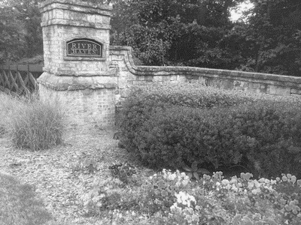*River Haven**

**ARCHITECTURAL CHANGE (ACC) REQUEST FORM**

Name: __________________________________________________ Date: ___________________________

Street Address: __________________________________________ City: ____________________ Zip: ___________

Daytime Phone: ___________________________________ Evening Phone: ________________________________

Email: ______________________________________________________ Fax: ______________________________

Proposed Start Date: ____________________________ Proposed Finish Date: _____________________________

**Project Type:** (Please check all applicable categories)

|  |  |  |  |
| --- | --- | --- | --- |
| □ Landscape | □ Arbor | □ Swimming Pool | □ Deck |
| □ Tree Removal | □ Play Equipment | □ Gazebo | □ Fence* |
| □ Paint House | □ Room Addition | □ Recreational Equipment | □ Other |
| □ Retaining Wall | □ Porch/Patio | □ Enclosure of Porch/Patio |  |

**Description of work**: ____________________________________________________________________________

**_____________________________________________________________________________________________**

**Is this request in response to a violation letter we sent you?** Yes□No□

**\* If this is a fence request, please answer the following:**

What is the height of the proposed fence? ______________ Material Type? ______________________________

What is the finish of the proposed fence? ______________________ (stain color, natural, unfinished etc.) Will the fence begin and end on the back corners of your home? Yes □ No □

If no, please explain: ____________________________________________________________________________

**Please attach the following:**

* Detailed written description of the proposed modification
* Attach supporting materials such as drawings, plans, paint samples, or brochures with photographs.

Homeowners are responsible for any building permits that may be required, building code compliance, survey of property lines, and arranging for required inspections and approvals. The homeowner herby grants permission to the ACC Committee to enter the property and make reasonable observation and inspections associated with the modification request and completion of the project.

**Homeowner Signature**: _________________________________________________________________________

***ACC Committee Use***

Date Received _________________________

□ Approved □ Approved w/Stipulations □ Denied □ Denied – Insufficient Information

Notification Via: □ US MAIL □ EMAIL

Comments: __________________________________________________________________________________

**Submit this form using one of the following options:**

**Email to:** ACC@RiverHavenHOA.com

**Mail to**: PO Box 46 Grayson, GA 30017